The 10th Global 5G Event Closes Successfully.

The 10th Global 5G Event was successfully held at LG Science Park ISC in Seoul, Korea, on October 30th and 31st, 2023. Due to the end of the COVID-19 pandemic, this event was conducted on-site only.
Korea’s 6G Forum hosted and organized this event, collaborating with the six leading 5G/6G organizations from around the world such as 5G Americas, 5G Brazil, IMT2020 (5G) PG from China, 6G-IA from European Union, Telecommunications Standards Development Society, India (TSDSI) from India, and 5GMF from Japan.

The global 5G event serves as a significant platform for sharing the latest trends in 5G achievements and discussing various topics related to mobile communication, global unified B5G technology standards, and industrial ecosystems. The event also covered discussions on 6G issues, in addition to 5G.
Over the course of one and half days, six sessions were conducted, focusing on Regional Policies for 5G/6G, 5G Business Model and Monetization, Evolution of 5G device and solutions, 5G+6G-Evolution of 5G Network towards 6G, Future service, technology, and socio-economic trends for 6G. A total of 29 invited speakers delivered excellent presentations during these sessions. Furthermore, a special session on 5G specialized Network and applications in Korea was organized by KT, LG Electronics, and ETRI.
Looking ahead, the 11th Global 5G Event will be held by India TSDSI in 2024.
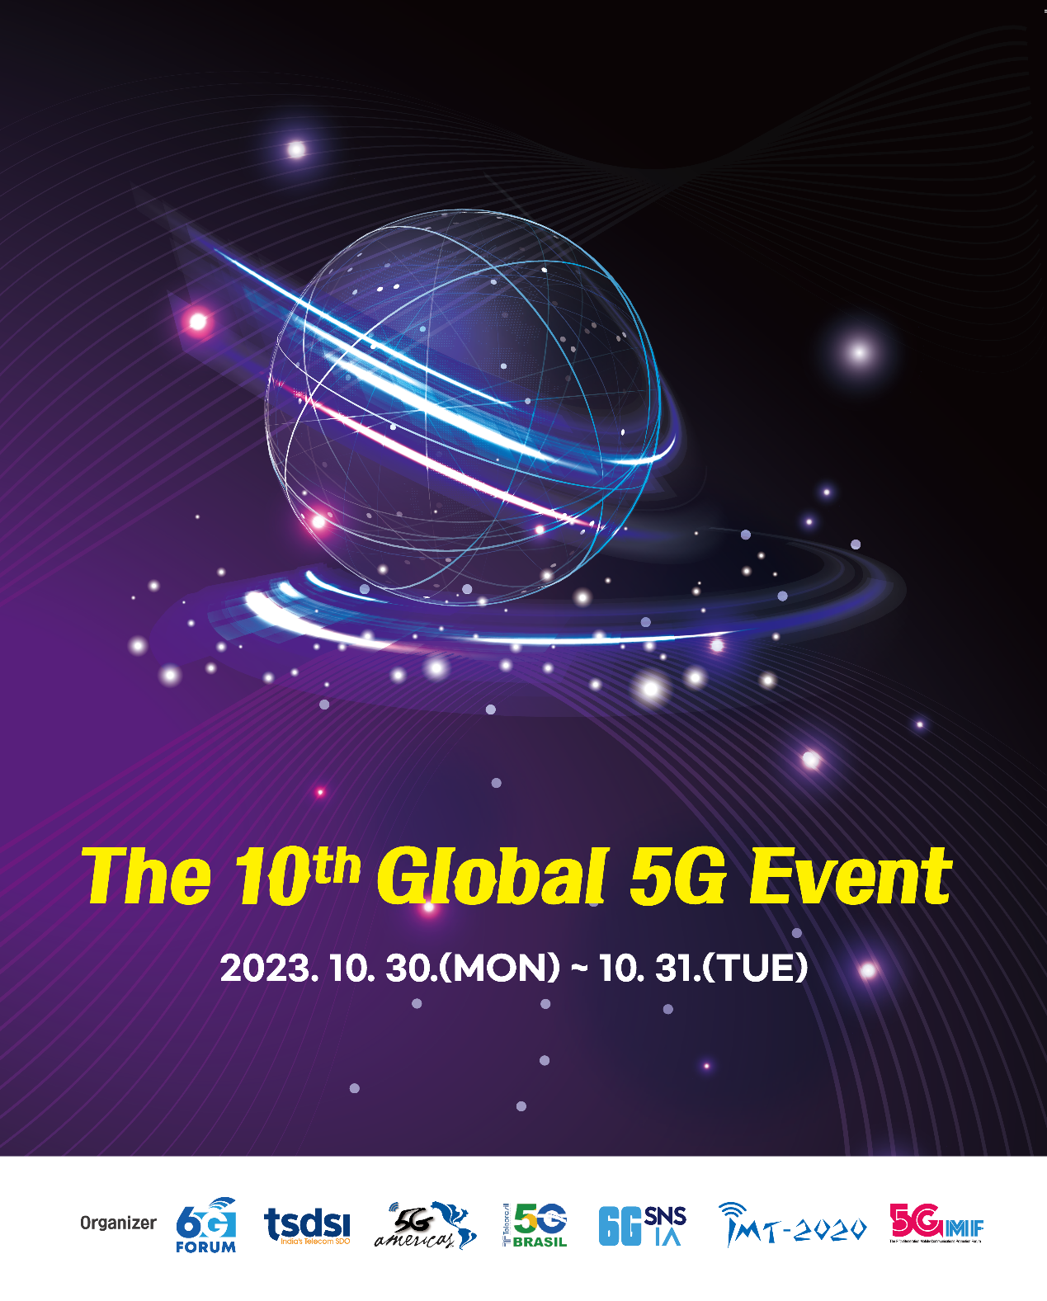
Global 5G Events MoU Signatories:
Prof. KyungHi Chang, Chair of the 6G Forum executive committee, said:
I am really pleased and honored to host the 10th G5GE and like to express my deepest gratitude to all the delegates, speakers, moderators, and TPC members in this event. I believe whole events provided the opportunity to share the current status of the 5G & 6G commercialization and RND across the continents to reinforce international collaboration. As we discussed during the event, let's keep extending the global collaborations for 5G Monetization & 6G Leadership.

Ms. Zhiqin Wang, Chair of IMT-2020（5G）PG, said:
The 10th Global 5G Event is a big milestone for 5G international cooperation. The 7 industrial organizations have come together again and made efforts for 5G & 5G-A large scale application. We believe it will certainly lay the foundations of 6G development in the years to come.

Dr. Alexandros Kaloxylos, Executive Director of 6G-IA, said：
The Global 5G event serves as an important platform to exchange information and trends for 5G networks at a global level. It is also a key opportunity to share priorities and ideas from each region for the further development of communication networks. I would like to thank the hosts of the 10th Global 5G event for a very successful organization of the event that help achieve a common understanding of the global status and identify key points that may lead to future globally accepted standards.

Mr. Chris Pearson, President of 5G Americas, stated:
“The 10th Global 5G Event in Seoul was a success and showcased the progress of 5G capabilities throughout the world. The latest 5G cellular innovations were highlighted at the conference by the new features in 5G Advanced that were presented and discussed.”

Prof. Emeritus Susumu Yoshida, Chair of the 5th Generation Mobile Communications Promotion Forum (5GMF), stated,
On behalf of 5GMF, I would like to highly appreciate the successful hosting of the 10th anniversary Global 5G Event by Korea 6G Forum. At this event, there were insightful presentations including the current deployment status of 5G services, new use cases and business models, and challenges such as accelerating the use of millimeter waves including R&D for tera-hertz band. These activities have effectively fulfilled the role of this event as a platform.
Triggered by this event, we hope to further accelerate the service deployment of full potentials of 5G, i.e., not only High-speed and/or High-capacity communications, but also Low-latency and/or Massive machine type communications over the next few years, and it requires a big vision to explore new use cases by integrating them with innovations such as AI and Digital Twins and so on. It is clear that for the successful introduction of 6G the smooth and extensive roll-out of the full 5G functionalities is a necessary prerequisite. Accordingly, we will continue to actively promote policies and technology development that meet mobile market demands, with an emphasis on 5G within the framework of 5G + 6G. It is also necessary to incorporate the results of standardization and R&D for realizing the goal smoothly.

Prof. Luciano Mendes, Research Coordinator of 5G Brasil, said:
The 10th edition of the Global 5G Event was an excellent opportunity not only to share what we are building with the deployment of 5G networks, but also to contribute for the development of the future 6G networks. Learning from the 5G networks to build the foundations for 6G networks is one important message from the outstanding event hosted in Korea this year.

Mr. N Mohanram, Director General of TSDSI, stated:
The 10th global 5G event facilitated sharing of insights on global 5G deployments, diverse business models and use case solutions. It initiated discussions on emerging B5G and 6G technology trends and regional policies, a dialogue set to continue in future events while keeping 5G as a primary focus.

Looking forward, the 11th Global event in 2024 will be hosted by TSDSI in India, currently experiencing the world’s fastest 5G deployment. Expect more on India’s deployment strategies and success stories.

